Definitive Abstract's Title (please use Arial, 14, bold, center)
Surname First Name^{1,a*}, Surname First Name^{2,b} and Surname First Name^{3,c}
¹Affiliation and address of authors of the first institution
²Affiliation and address of authors of the second institution
³List all distinct affiliation and full addresses of authors in the same way
ª*e-mail (corresponding author), ^{b}e-mail, ^{c}e-mail
Keywords: keyword1; keyword2; keyword3; keyword4; keyword5.
Abstract.
For the rest of the abstract, please use Times Roman (Times New Roman); 12; page settings: A4 format (21 x 29.7 cm or 8 x 11 inches); the margins: top 2.5 cm (0.98 in), bottom 1.5 cm (0.59 in) and right/left 2 cm (0.78 in); do not number the page. The size of your manuscript will be reduced by approx. 20 % by the publisher for the print version.
All text, figures and tables must be in English. As this is a one-page abstract of your conference paper, there is no need to organize the text into sections.
Figures (Fig. 1, Fig. 2,...) should be presented as part of the text. A descriptive title should be placed below or beside the figure. Only original figures of very good resolution (at least 300 dpi) are acceptable. Color figures (welcome for the online version) will be reduced to black and white for the print version.

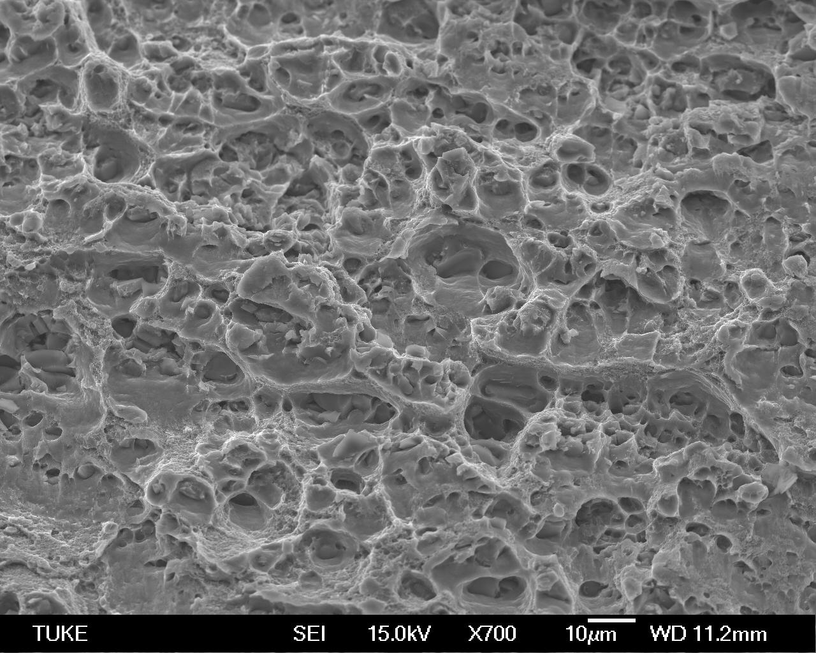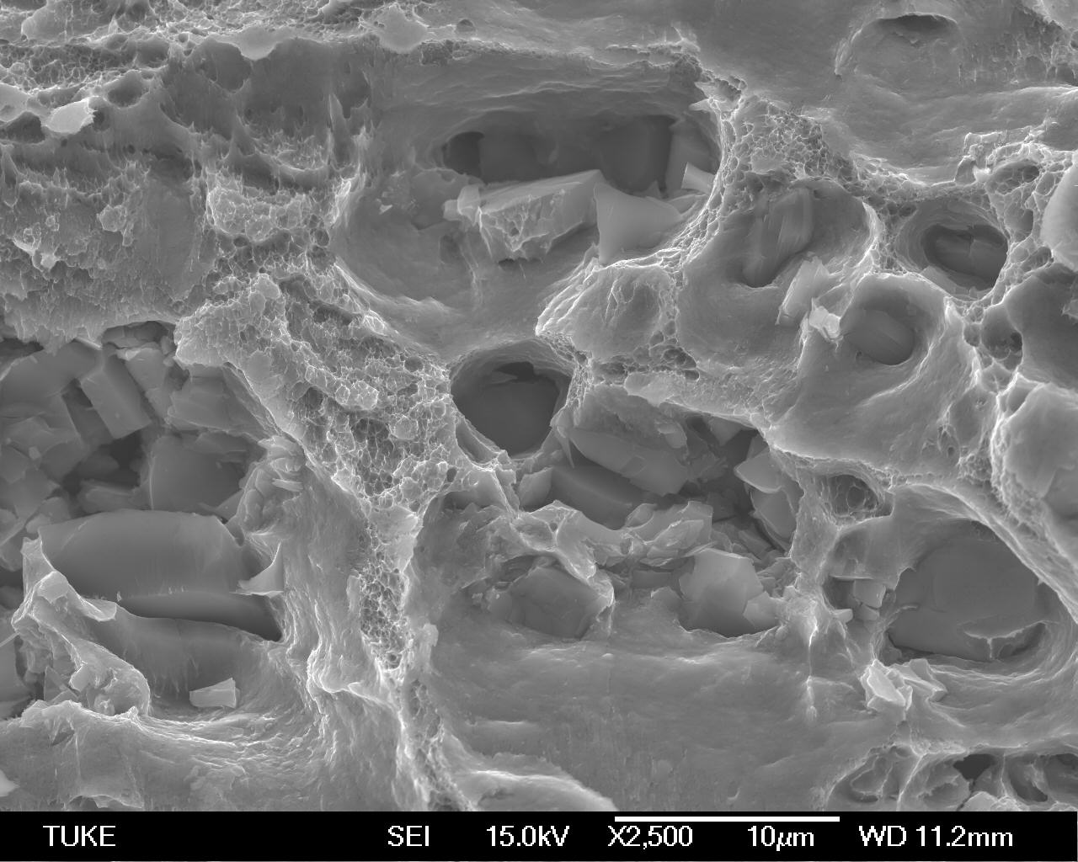
Fig. 1 Fracture surfaces of ...

Tables (Table 1, Table 2,...) should be presented as part of the text. A descriptive title should be placed above each table. Do not use any macros for the figures and tables. We will not be able to convert such papers into our system.

Table 1 Chemical composition of ... [wt. %]
 | X | Y | Z
material | 10.00 | 10.00 | 80.00
Acknowledgment (if necessary)
There is a place for acknowledgment.
References (if necessary)
[1] A.B. Cain, D.E. Fine, Title of Paper, Journal 11 (2021) 22-33.
[2] G. High, et al., Title of Book, 4th ed., Publisher, City, 2021.
[3] I.J. Key, Title of Capture, in: L.M. New (Ed.), Title of Handbook, Publisher, City, 2021, 44-55.

